**List of Technologies**

* HTML
* CSS
* Javascript
* JQuery
* Maven & Spring Framework
* Spring Boot
* Kafka

HTML: Hyper Text Markup Language

CSS: Cascading Style Sheet

Web development, there are 3 technologies are used

1. HTML: It is to display the content
2. CSS: It is to style the HTML
3. Javascript: It is to add effects dynamically and add HTML / CSS at runtime

Editors

1. VS Code
2. Eclipse

HTML

Heading tags: h1, h2, h3, h4, h5, h6

<h1>some content</h1>  
<h2>some content</h2>

Paragraphs: These contents are used to display the paragraphs, which gives a line break before & after the paragraph

bold & italic tags: <b> & <i>, these tags doesn’t have line breaks, these are used inline

<p>Some content <b> few more contents </b> again some more </p>

Self closing tags: These tags don’t have closing, they can be closed with the start tag itself

<hr />: Horizontal rule  
<br />: This is to give a line break  
<img />: This to display the image

Attributes: These are some extra information’s given to the tag, they appear in the start tag

ex: <img src=”url” width=”200” height=”200” />

Marquee: It makes content to move

Entities: These are some special characters which can be displayed using some entity names or numbers

&copy; this creates a copyright symbol  
&reg; this is to create registered mark  
t; for < symbol  
&gt; for > symbol

&#8377; creates rupee symbol

Links & Lists

anchor tag is used to create the link <a href=”url”>LinkName</a>  
<a href=”url” target=”_blank”>LinkName</a>

Lists: There are 2 types

1. ordered <ol>
2. unordered <ul>

<li> it is the list index or list item that comes inside the ordered/unordered lists

Tables: <table> tag is used to create tables, it will have 2 child tags <thead> & <tbody> to create table headings & table contents respectively, both uses <tr> to create rows, to create columns we have <th> & <td>, <th> is used for heading purpose, <td> is used in the table body.

div: It is a container tag that can wrap other HTML tags, this is mainly to group the HTML tags & style them later

Forms: These allow to create forms that user can input, like text, checkbox, radio buttons, drop downs, buttons, password, text area, range bar, progress bar, file upload

Form comes with 2 attributes

1. action: Carries the server URL where the data needs to be submitted
2. method: This specifies the HTTP methods like GET / POST, which tells whether form data must be submitted through URL (GET) or through the body (POST)

Note: Default form submission is GET i.e., sends data through URL, hence its advisable to specify method=”post”

Usage:

<form action=”#” method=”post”>  
 <label>Enter Name</label>  
 <input type = “text” name = “username” />  
 <label>Enter Password</label>  
 <input type=”password” name=”secret” />  
 <!-- for drop down -->  
 <select name=”qualification”>   
 <option value=”btech”>BTech</option>  
 <option value=”mtech”>MTech</option>  
 </select>  
 </form>

CSS: Cascading Style Sheet, you can apply CSS in 3 ways

1. Inline CSS: applied on a particular element using style attribute
2. Internal CSS: applied to the whole HTML document, using <style> tag
3. External CSS: applied to multiple HTML documents by creating a CSS file, CSS file needs to be linked using <link> tag

Syntax: property : value; property : value;

CSS Selectors: These help in selecting the HTML elements, there are mainly 3 types of selectors

1. tag selector: to select the element using tag name

p { color : blue }  
h2 { color : red }

1. id selector: to uniquely select an element using the element id

#a { color : blue }  
#b { color : red }  
<p id = “a”> & <h2 id = “b” >

1. class selector: to select multiple elements using the class name

.i1 { color : blue }   
.i2 { color : red }  
<p class = “i1”> & <h2 class = “i1”>

3rd party CSS: These are predefined CSS provided by CSS communities that can be used anywhere in the world

ex: bootstrap, semantic-ui, angular-materials, primefaces, tailwind

Bootstrap common class-names

Button: btn btn-primary, btn-secondary, btn-success, btn-danger,

Forms: form-control, form-control-lg

div: container-fluid, container

Tables: table, table-striped

Activity: Align the Form to the center of the page

Javascript: It adds dynamic effects to your web page by accessing HTML & CSS at runtime, apart from modifying HTML & CSS it can also perform following operations

1. Validations
2. Event Handling

<script> tag is used to add javascript to your html

Fundamentals of Javascript

1. Variables
2. Functions
3. Operators
4. Conditional Statements
5. Arrays
6. Loops
7. Objects
8. Events

Our first JS program

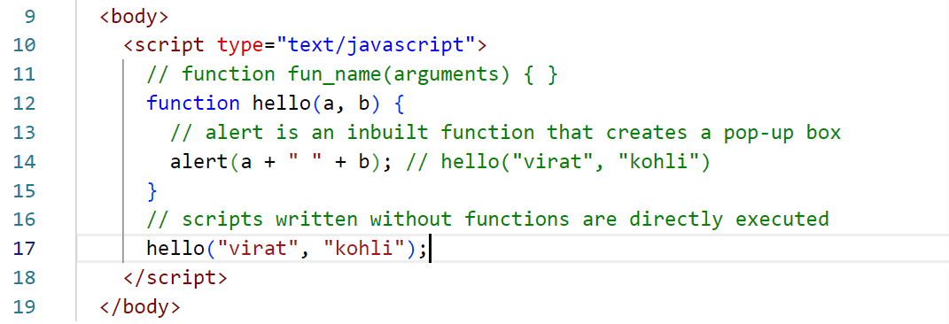

Output  
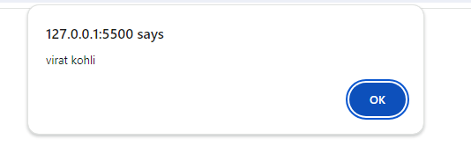

How to generate events & handle these events

Events are anything that happens on browser, it could be click, mouse over, mouse out, form submit, input focus, input blur, all these events can occur on any HTML element

<tagName onclick=”fn()”>Some content</tag>

Program that generates click event on an HTML element

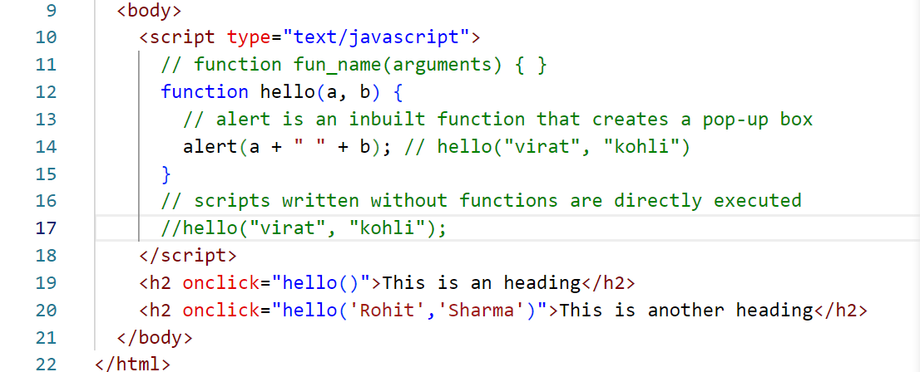

Output:

